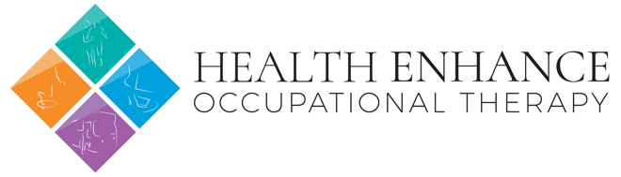  Health of Nation Outcome Scale |  |  | UR:  Surname:  Given Name:  Address:  DOB: Sex:
Rating Period:

Scoring: 0= no problem, 1= Minimal problem, 2= Moderate problem, 3= Substantial problem, 4= Severe problem, 9= Unknown/ Not app

Question 8: A- Phobic, B- Anxiety, C- OCD, D- Stress, E- Dissociative, F- Somatoform, G- Eating, H- Sleep,
I- Sexual, J- Other

HoNOS |  | 7) Problems with depressed mood
1) Overactive, aggressive, disruptive, agitated behaviour |  | 8) Other mental and behavioural (above) |  | [ letter/ score]
2) Non accidental self-injury |  | 9) Problems with relationships
3) Problem drinking or drug taking |  | 10) Problems with activities of daily living
4) Cognitive problems |  | 11) Problems with living conditions
5) Physical illness or disability problems |  | 12) Problems with residential rehabilitation participation and activities
6) Problems associated with hallucinations/ delusions |  | TOTAL
Therapist Name: Therapist Signature: Date:

HoNOS

