|  |  |
| --- | --- |
| **Life Skills Profile** | **UR:**  **Surname:**  **Given Name:**  **Address:**  **DOB:**  **Sex:** |

**Life Skills Profile**

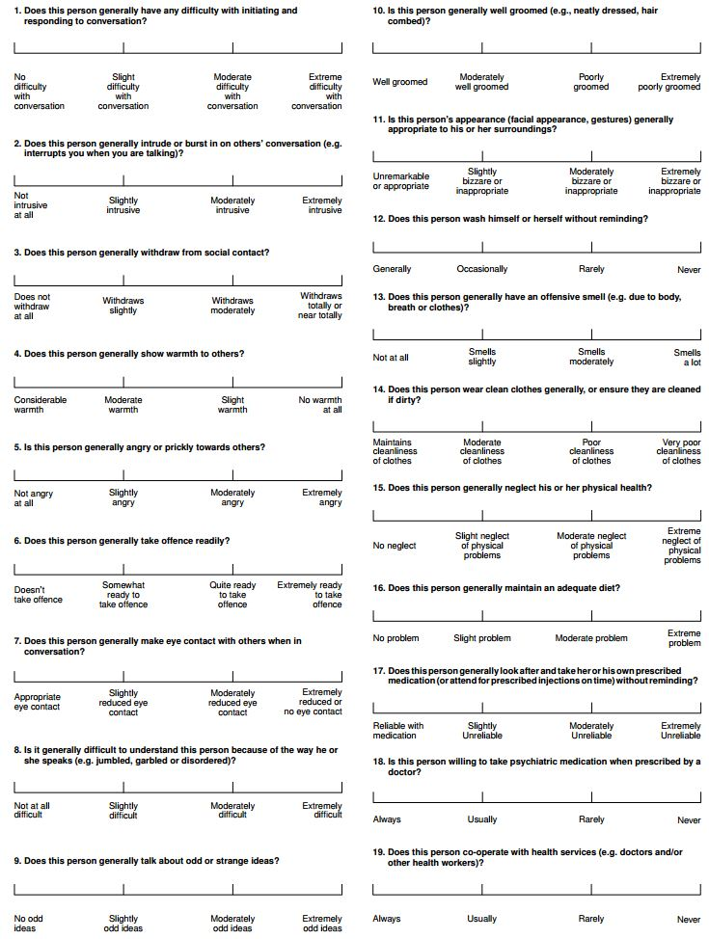

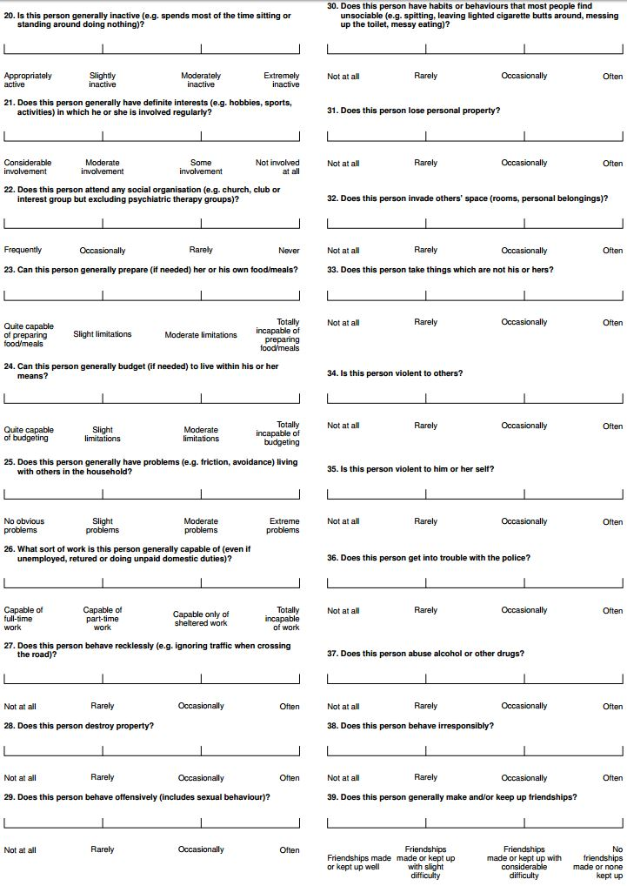

|  |  |
| --- | --- |
| Completed by: |  |
| Date: |  |

